INVITATION FOR BID
No. 018

- SALE METHOD:
Electronic BID by emailing moxproperty@moxproject.com or mailing to the MOX Services Agreement Administrator identified in clause 2A below.

- PREPARATION/SUBMITTAL OF BIDS
  - MOX Services has established an emailing address, paper mailing address and a CB&I AREVA MOX Services, LLC (MOX Services) web site to be used for the posting of the initial Invitation for Bid (IFB) documents, and Amendments, if applicable. Questions will be submitted to MOX Services email address or mailing address. If you experience any problems with the email address or if you need further assistance, contact the MOX Services Agreement Administrator,
Guy Larkin
CB&I AREVA MOX Services, LLC
P.O. Box 7097
Savannah River Site
Building 706-5F, Office #212
Aiken, SC 29802
Phone: 803-819-2152
Email: moxproperty@moxproject.com

  - Bidders are expected to examine the complete IFB, including drawings, specifications, and the Sales Agreement. documents, including attachments, all instructions and IFB amendments. Failure to do so will be at the Bidder’s risk and no relief for errors or omissions by the Bidder will be given, after Agreement award. It is understood and agreed that all actions taken and information furnished by the Bidder as a result of this IFB are at no cost or obligation to MOX Services and shall not be construed as an obligation on the part of MOX Services to enter into an Agreement with the Bidder, whether or not the requirements reflected in this IFB are terminated or modified.

  - Each bid shall show the full legal name and business address of the Bidder, including its street address, if it differs from the mailing address, and shall be signed bearing the original signature by the person or persons authorized to bind the Bidder, and shall be dated.

  - A cashier or certified check, bank draft, postal or express money order made out to CB&I AREVA MOX Services, LLC in the full amount of the bid price and the fully executed Sales Agreement (including Attachment A Excess Property Bid Sheet) must be received by the MOX Services Agreement Administrator identified in clause 2 above no later than 4 working days after notification of award to the successful Bidder.

  - Regardless of whether a bid is submitted by mail or email, the following is the minimum documentation needed to be considered for a bid:

    - The appropriate and properly completed Excess Property Bid Sheet for each sale.
    - The appropriate and properly completed Sales Agreement for each sale.

- BID PRICE:
Is price per each, times the quantity identified per line item.

- EXCESS PROPERTY DESCRIPTION:
See Attachment A Excess Property Bid Sheet to the Sales Agreement.

- EXCESS PROPERTY LIST/BID SHEET:
See Attachment A Excess Property Bid Sheet to the Sales Agreement.

- SALE DATE:
Bidding opens at 9:00AM EST, 02Feb15 and closes at 3:00 PM EST, 27Feb15.
.

Invitation To Bid #: 018

- PAYMENT TYPE:
A cashier or certified check, bank draft, postal or express money order check made out to CB&I AREVA MOX Services, LLC

- REMOVAL OF PROPERTY:
Must be completed within 24 calendar days after the date of the award of the Sales Agreement.

- SALE TERMS:
Full purchase price must be received prior to picking up material and within four (4) working days from date of award of Sales Agreement.

- LOCATION OF SALE:
CB&I/AREVA MOX Services, LLC, SRS Laydown Yard A, Aiken, SC 29808

- SELLER WILL LOAD:
Seller will make arrangements to load the conveyance(s) provided by the Purchaser.

- MOX SERVICES CONTACT PERSONNEL:
Personnel at Property Location:
Roseanne Redd
email moxproperty@moxproject.com
Phone 803-819-2152

MOX Services Agreement Administrator:
Guy Larkin
email moxproperty@moxproject.com
Cell phone 803-443-2522

- PROPERTY CONDITION:
All property listed herein is offered for sale "as is" and without recourse against MOX Services or the Government. The description is based on the best available information, but MOX Services and the Government make no guaranty, warranty, or representation, expressed or implied, as to quantity, kind, character, quality, weight, size, or description of any of the property, or its fitness for any use or purpose; no claim will be considered for allowance or adjustment or for rescission of the sale based upon failure of the property to correspond with the standard expected; this is not a sale by sample.

- CONSIDERATION OF BIDS:
  - Telegraphic or telephonic bids will not be accepted.
  - The Bidder agrees that his/her bid will not be withdrawn within the period of time specified for the acceptance thereof following the opening of bids (60 calendar days) and that during such period his/her bid will remain firm and irrevocable. The MOX Services reserves the right to reject any or all bids, including bids under which a Bidder could take unfair advantage of the Government or other Bidders, to waive any technical defects in bids, and unless otherwise specified by the MOX Services or by the Bidder, to accept any one item or group of items in the bid, as may be in the best interest of the Government. Unless otherwise provided in the Invitation, bids may be submitted on any or all items. However, unless the Invitation otherwise provides, a bid covering any listed item must be submitted on the basis of the unit specified for that item and must cover the total number of units designated for that item.

- BID PRICE DETERMINATION:
  - Line item bids are solicited on a unit price basis. Bidders will insert their unit price and extend the total price per line in the space provided for each item.

Invitation To Bid #: 018

  - In the event the Bidder inserts a total price on the item but fails to insert a unit price, MOX Services will determine the unit price by dividing the total price by the quantity of the item set out in the Invitation. The unit price so determined shall be used for the purpose of bid evaluation, award and all phases of agreement administration.
  - When bids are solicited on a "lot" basis, Bidders should submit a total price on the bid sheet.

- ELIGIBILITY OF BIDDERS:
The Bidder warrants that he/she is not under 18 years of age.

- PERSONS PROHIBITED FROM OR LIMITED IN BIDDING:
If the Bidder is in any way affiliated with MOX Services, the U.S. Department of Energy, he/she hereby represents that he/she:
  - Has not participated in MOX Services determination to dispose of the property;
  - Has not participated in the preparation of the property for sale; and
  - Has not participated in determining the method of sale.

- LATE BIDS, MODIFICATION OF BIDS, OR WITHDRAWAL OF BIDS:
Any bid received after the time specified for receipt may not be considered, except under the following conditions: (A) it is the only bid received, or (B) it is advantageous to MOX Services to accept late bids. Bids may be withdrawn by written notice received at any time prior to the date and time specified for receipt of bids.

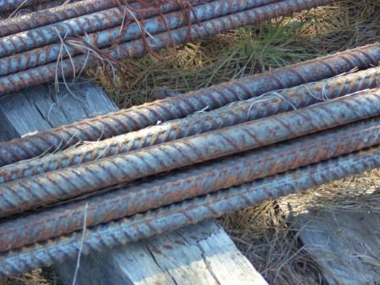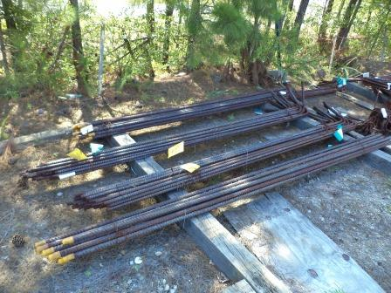

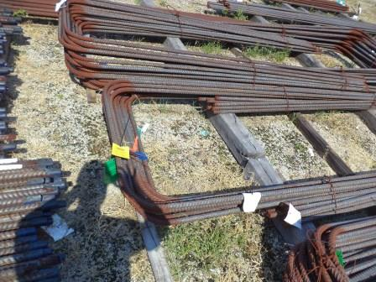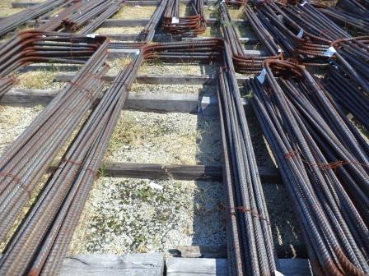

Invitation To Bid #: 018

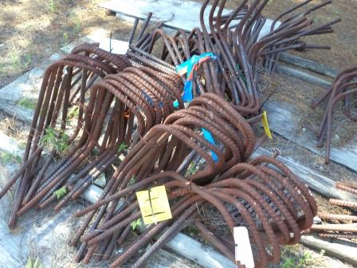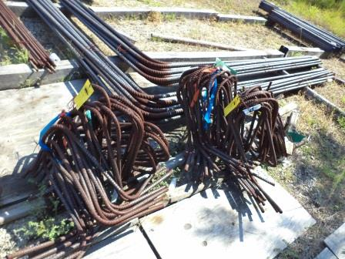

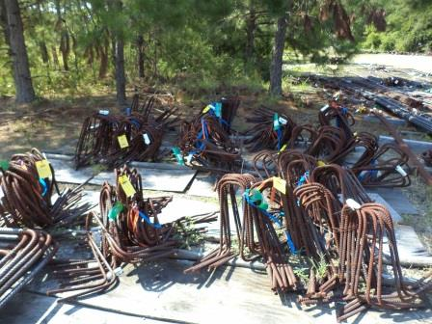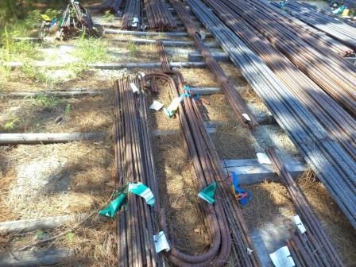

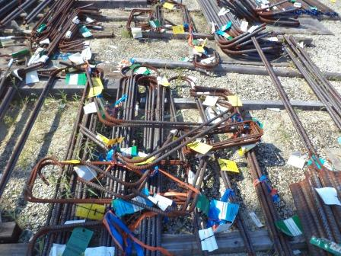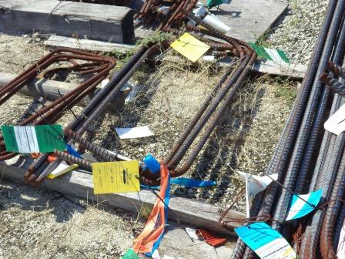

Invitation To Bid #: 018

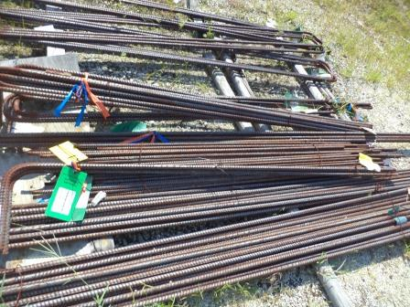

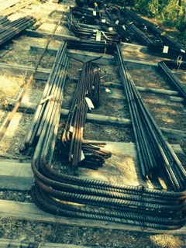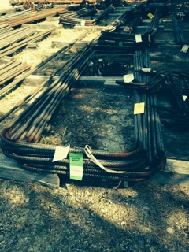

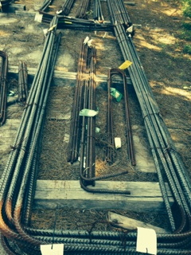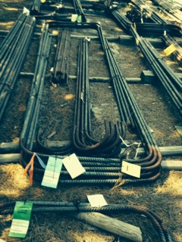

Invitation To Bid #: 018

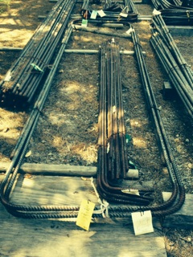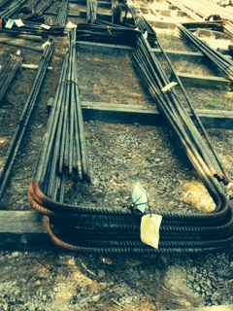

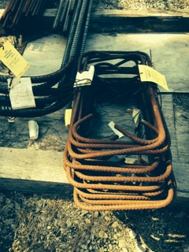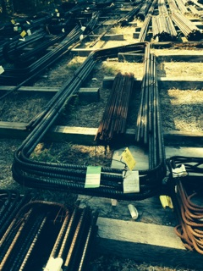

Invitation To Bid #: 018

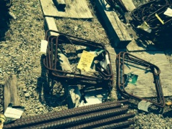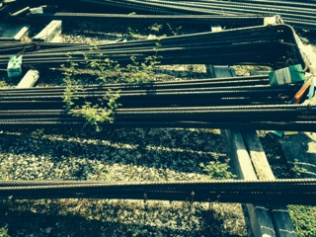

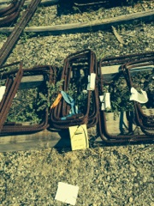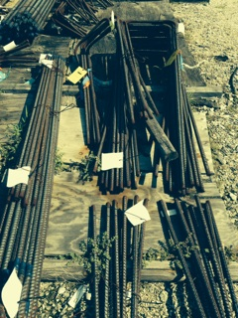

Invitation To Bid #: 018

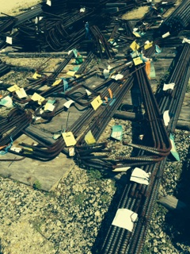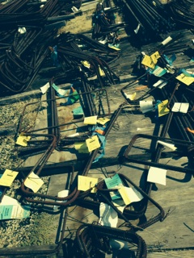

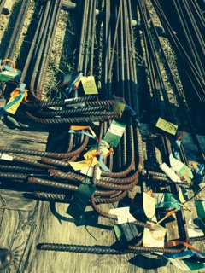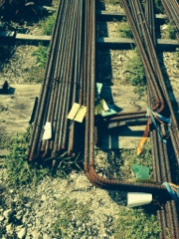

Invitation To Bid #: 018

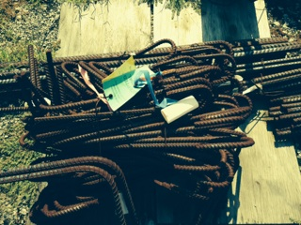

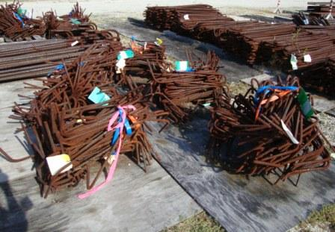

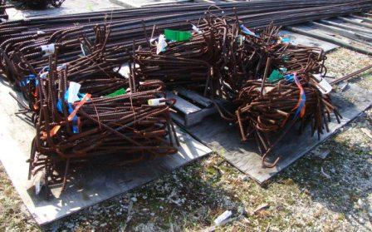

Invitation To Bid #: 018

